PROJECT REPORT OF CO-OP Project at Industry (Module-2)
ON
A Data Science Approach for Analyzing Music Industry Trends

submitted in partial fulfillment of the requirements for the award of degree of

BACHELOR OF ENGINEERING
In
COMPUTER SCIENCE AND ENGINEERING

Submitted by: Supervised By:
Ansh Puri Dr.Simarjit Kaur Virk
2210990139 Associate Professor



DEPARTMENT OF COMPUTER SCIENCE AND ENGINEERING

CHITKARA UNIVERSITY INSTITUTE OF ENGINEERING AND TECHNOLOGY
CHITKARA UNIVERSITY, PUNJAB, INDIA

CONTENTS

S.No. | Title | Page No.
 | Acknowledgement | 4
 | List of Figures and Tables | 5
 | Abstract | 6
1 | Introduction | 7
2 | Methodology | 8
3 | Tools and Technologies | 9
4 | Implementation | 10
5 | Major Findings/Outcomes/Output/Results | 11
6 | Conclusion and Future Scope | 12
 | References | 13
 | Appendices | 14

DECLARATION

I hereby certify that the work which is being presented in the project report entitled A Data Science Approach for Analyzing Music Industry Trends in partial fulfillment of requirement for the award of the degree of Bachelor of Engineering (Computer Science and Engineering) submitted in the department of Computer Science and Engineering at Chitkara University Institute of Engineering and Technology, Chitkara University, Punjab, India, is an authentic record of my own work carried out under the supervision of Dr.Simarjit Kaur Virk The matter presented in this project report has not been submitted in any other university/institute for the award of any degree.

Place: Rajpura Ansh Puri
2210990139
Date-30th April,2026

This is to certify that the above statement made by the candidate is correct to the best of my knowledge and belief.

Dr.Simarjit Kaur Virk
Associate Professor
Department of Computer Science and Engineering
Chitkara University Institute of Engineering and Technology,
Chitkara University, Punjab, India

ACKNOWLEDGEMENT

The author would like to express a sincere gratitude to the faculty and mentors at Chitkara University for their guidance and support during the development of this research paper.Special appreciation is extended to the mentor of this project for their consecutive feedback and suggestions.The author also acknowledges the contribution of online platforms such as Spotify and Kaggle for the datasets access for this study.

LIST OF FIGURES AND TABLES

S.NO | Title | Page no.
1.Fig 1 | Workflow of the system | 2
2.Table 1 | Tables and dataset columns | 2
3.Fig 2. | .Relationship between energy and popularity | 3
4.Fig 3. | .Relationship between danceability and popularity | 3
5.Fig 4. | Relationship between tempo and popularity | 3
6.Fig 5.. | Correlation Heatmap of the auido features | 4
7.Fig 6. | Linear Regression in prediction results. | 4
8.Fig 7. | Decision Tree prediction results. | 4
9.Fig8. | Random Forests prediciton results | 4
10.Fig9. | Neural Network prediciton results | 5
11.Table 2. | Performance comparision of the models | 5

ABSTRACT

In this world the systems are very advanced as they gather bunch of data from the internet are making an impact in the digital era as of now.The major purpose of this project is to use different machine learning algorithms and statistical methods to analyze the audio features of the songs.In this research paper I have used a various number of models,as I am very much curious to know what makes a song popular and gain some knowledge about the factors influencing the growth of the songs in today’s fastest growing world.This research paper would help the people who want to forecast the reason of success of products in the music
industry as they influence a lot in the song’s success.With the help of this research paper I would aim to shed light on the relation of audio features and song’s popularity and would know the elements that make a song hit or flop,and would make predictive model to predict the song’s stats.I think that my study would offer an essential contribution in this area of research.

- Introduction

1.1 Overview
In this world the systems are very advanced as they gather bunch of data from the internet are making an impact in the digital era as of now.The major purpose of this project is to use different machine learning algorithms and statistical methods to analyze the audio features of the songs.In this research paper I have used a various number of models,as I am very much curious to know what makes a song popular and gain some knowledge about the factors influencing the growth of the songs in today’s fastest growing world.This research paper would help the people who want to forecast the reason of success of products in the music
industry as they influence a lot in the song’s success.With the help of this research paper I would aim to shed light on the relation of audio features and song’s popularity and would know the elements that make a song hit or flop,and would make predictive model to predict the song’s stats.I think that my study would offer an essential contribution in this area of research.
1.2 Problem Statement
This study solves the problem of understanding and predicting song popularity using audio features. By applying machine learning models to a real-world Spotify dataset, the work identifies key patterns and evaluates the effectiveness of different models. The results help in understanding how audio features influence popularity and highlight the limitations of prediction using only these features.
1.3 Background of the project

In recent years, the music industry has undergone a significant transformation with the rise of digital streaming platforms such as Spotify. These platforms provide users with instant access to millions of songs, making music consumption more convenient than ever before. As a result, a vast amount of music-related data is generated, including information about song characteristics and user listening behavior.

This availability of large-scale data has created new opportunities for analysis using data science and machine learning techniques. Researchers and analysts are increasingly interested in understanding how different audio features, such as tempo, energy, and danceability, influence the popularity of songs.
not only by audio features but also by external factors such as artist reputation, marketing strategies, and social media trends.

2.Methodology

The methodology of this project follows a structured approach to analyze and predict song popularity using machine learning techniques. The overall process consists of data collection, preprocessing, feature analysis, model development, and evaluation.

Data Collection
Firstly, the dataset is collected from a publicly available Spotify dataset on Kaggle. The dataset contains approximately 3000 songs along with various audio features such as tempo, energy, danceability, loudness, and popularity scores.

Data Preprocessing
In the preprocessing stage, the dataset is cleaned to ensure accuracy and consistency. Missing values are handled, and unnecessary or irrelevant features are removed. Numerical features are normalized to bring them to a similar scale, which helps improve the performance of machine learning models.

Feature Analysis
After preprocessing, feature analysis is performed to understand the relationship between different audio features and song popularity. Visualization techniques such as scatter plots and correlation heatmaps are used to identify patterns and dependencies within the data.

Predictive Modelling
Next, multiple machine learning models are applied, including Linear Regression, Decision Tree, Random Forest, and Neural Networks. The dataset is divided into training and testing sets in an 80:20 ratio to evaluate the performance of these models. Linear Regression is used as a baseline model, while Decision Tree and Random Forest are used to capture non-linear relationships. Neural Networks are applied to model more complex patterns in the data.

Finally, the performance of each model is evaluated using metrics such as Mean Squared Error (MSE) and R-squared (R²). These metrics help in comparing the accuracy and effectiveness of the models in predicting song popularity.

3.Tools and Technologies

The following tools and technologies were used in the development of this project:

1. Python: Used as the primary programming language for data analysis and model implementation.

2. NumPy: Used for numerical computations and handling array-based data efficiently.

3. Pandas: Used for data manipulation, cleaning, and preprocessing of the dataset.

4. Matplotlib and Seaborn: Used for data visualization, including graphs and correlation analysis.

5. Scikit-learn: Used for implementing machine learning models such as Linear Regression, Decision Tree, and Random Forest.

6.TensorFlow/Keras: Used for building and training the Neural Network model.

- Kaggle: Used as the source of the Spotify dataset for analysis.

4.Implementation
The implementation of this project was carried out using Python in a Jupyter Notebook environment. The complete workflow was executed step-by-step, starting from data loading to model evaluation.

Initially, the dataset was imported from Kaggle and loaded into the environment using the Pandas library. Basic exploration was performed to understand the structure of the dataset, including checking the number of rows, columns, and data types of each feature.

In the next step, data preprocessing was performed. Missing values were handled, and unnecessary columns were removed. The dataset was then prepared for analysis by selecting relevant features such as tempo, energy, danceability, and loudness. Feature scaling was applied to normalize the data, especially for improving the performance of machine learning models.

After preprocessing, data visualization techniques were applied using Matplotlib and Seaborn. Scatter plots and heatmaps were generated to understand the relationships between audio features and song popularity.

Following this, the dataset was split into training and testing sets in an 80:20 ratio. Multiple machine learning models were then implemented, including Linear Regression, Decision Tree, Random Forest, and Neural Networks. These models were trained using the training data and evaluated on the testing data.

Finally, model performance was analyzed using evaluation metrics such as Mean Squared Error (MSE) and R-squared (R²). The predictions generated by each model were compared with the actual values to assess accuracy and effectiveness.

5.Results
The results were as follows as seen in the Table6
S.NO | Model | MSE | R²
1. | Linear Rgeression | 585.91 | 0.056
2. | Decision Tree | 845.27 | -0.361
3. | Random Forest | 458.09 | 0.262
4. | Neural Network | 563.95 | 0.091

From the results, Random Forest performs the best with the lowest MSE and highest R² value.Decision Tree shows the worst performance due to overfitting. Linear Regression and Neural Network give moderate results.
Overall, the results indicate that Random Forest is more suitable for task. However, audio features alone are not enough to accurately predict song’s popularity.
The following are the figures that were being produced during the study,various algorithms have been used over here.
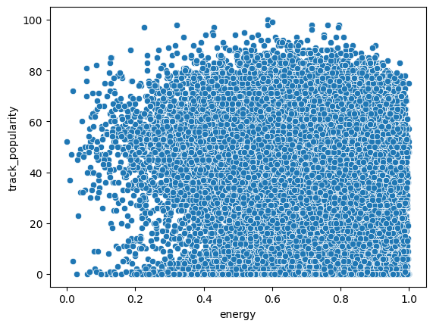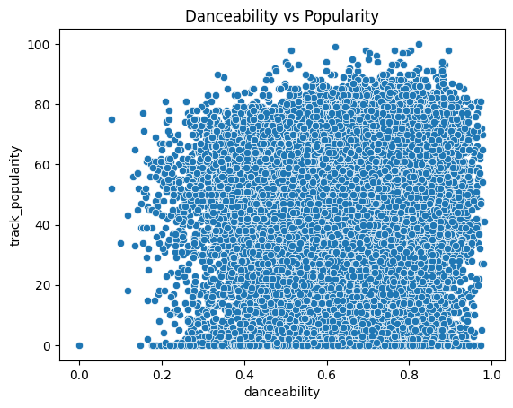
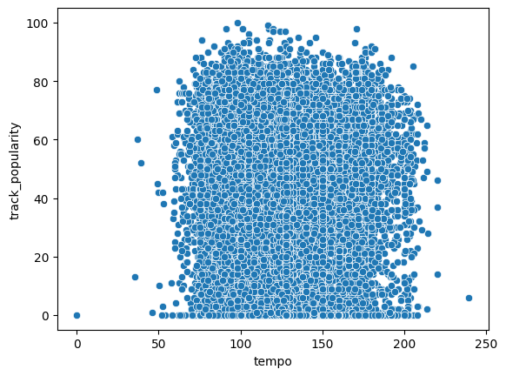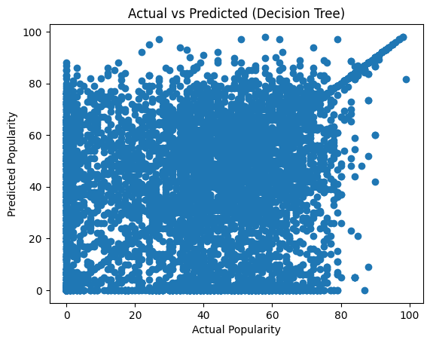
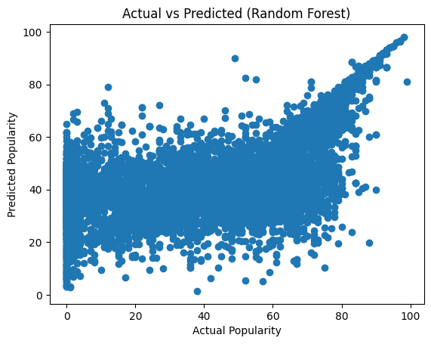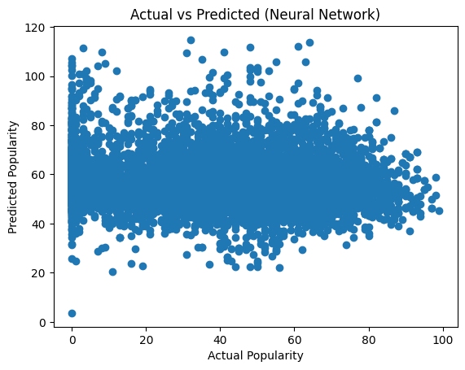

6.Conclusion and Future Scope
As we know that in this digital era,many models have been emerged.The field of music production and the analysis have gone much deeper and they have transformed very much in these recent years,this is because I have researched about it and saw many articles on this same topic and tried to grasp some ideas from good research papers.In this study I found that the popularity of the song does not depend fully on the audio features but together they make a bit difference.In this study I found that the danceability and other features did not go as expected but due to the taste of people in music has made it sure that we cannot expect a feature to be directly depending on the popularity,many other features were also giving the same results and they also showed that the features alone cannot be directly depending or influencing the popularity ,machine learning models make that sure the predictive model can find out the patterns affecting popularity.

I truly think that working on a large dataset shows the difference in the tastes of the people.Audio features alone cannot be the factor for the popularity ,lyrics of the songs and the music production as well contributes to the same.

The model can help the music streaming services to know the real reason behind the success.Hence no on could even predict that but these models can give a rough idea by the insights they provide and give the companies and labels an idea that the songs could be made in a manner that affects masses and generate great revenues.

- References

[1] Spotify, "Spotify Official Website." [Online]. Available: https://www.spotify.com

[2] Kaggle, "Spotify Dataset." [Online]. Available: https://www.kaggle.com

[3] F. Pedregosa et al., "Scikit-learn: Machine Learning in Python," Journal of Machine Learning Research, 2011.

[4] C. R. Harris et al., "Array programming with NumPy," Nature, 2020.

[5] W. McKinney, "Data Structures for Statistical Computing in Python," Proc. SciPy, 2010.

[6] S. Bhavanasi et al., "Spotify Data Analysis and Song Popularity Prediction," 2022.

[7] J. Brownlee, "Machine Learning Mastery with Python," Machine Learning Mastery, 2016.

[8] L. Breiman, "Random Forests," Machine Learning, vol. 45, no. 1, pp. 5–32, 2001.

[9] T. Hastie, R. Tibshirani, and J. Friedman, "The Elements of Statistical Learning," Springer, 2009.

[10] D. P. Kingma and J. Ba, "Adam: A Method for Stochastic Optimization," 2015.

[11] I. Goodfellow, Y. Bengio, and A. Courville, "Deep Learning," MIT Press, 2016.

[12] A. Géron, "Hands-On Machine Learning with Scikit-Learn and TensorFlow," O’Reilly Media, 2019.

[13] K. Murphy, "Machine Learning: A Probabilistic Perspective," MIT Press, 2012.

[14] J. Han, M. Kamber, and J. Pei, "Data Mining: Concepts and Techniques," Elsevier, 2011.

[15] B. McFee et al., "librosa: Audio and Music Signal Analysis in Python," Proc. SciPy, 2015.

[16] M. Müller, "Fundamentals of Music Processing," Springer, 2015.

[17] Y. Hu, X. Chen, and D. Yang, "Music Recommendation Based on Audio Features and User Preferences," IEEE Access, 2018.

[18] R. Knees and M. Schedl, "Music Similarity and Retrieval: An Introduction," Springer, 2016.

[19] G. Tzanetakis and P. Cook, "Musical Genre Classification of Audio Signals," IEEE Transactions on Speech and Audio Processing, 2002.

- S. Dieleman and B. Schrauwen, "End-to-End Learning for Music Audio," IEEE ICASSP, 2014.

- Appendices
Appendix A: Technical Stack and Environment
Language-Python
Environment-Google Colab
Appendix B: Code Logic (Python)
Code showing the feautres in the dataset
features = [
'danceability',
'energy',
'loudness',
'speechiness',
'acousticness',
'instrumentalness',
'liveness',
'valence',
'tempo'
]
Code showing the target feature for the study
target='track_popularity'

